**PRACTICAL 08**

**AIM: *Write a program to implement Cohen Sutherland Line Clipping Algorithm.***

**SOFTWARE REQUIRED: TURBO C++**

**PROGRAM:**

#include"stdio.h"

#include"conio.h"

#include"graphics.h"

void main()

{

int gd=DETECT, gm;

float i,xmax,ymax,xmin,ymin,x1,y1,x2,y2,m;

float start[4],end[4],code[4];

clrscr();

initgraph(&gd,&gm,"C:\\TURBOC3\\BGI");

printf("\n\tEnter the bottom-left coordinate of viewport: ");

scanf("%f %f",&xmin,&ymin);

printf("\n\tEnter the top-right coordinate of viewport: ");

scanf("%f %f",&xmax,&ymax);

printf("\nEnter the coordinates for starting point of line: ");

scanf("%f %f",&x1,&y1);

printf("\nEnter the coordinates for ending point of line: ");

scanf("%f %f",&x2,&y2);

for(i=0;i <4;i++)

{

start[i]=0;

end[i]=0;

}

m=(y2-y1)/(x2-x1);

if(x1 <xmin) start[0]=1;

if(x1 >xmax) start[1]=1;

if(y1 >ymax) start[2]=1;

if(y1 <ymin) start[3]=1;

if(x2 <xmin) end[0]=1;

if(x2 >xmax) end[1]=1;

if(y2 >ymax) end[2]=1;

if(y2 <ymin) end[3]=1;

for(i=0;i <4;i++)

code[i]=start[i]&&end[i];

if((code[0]==0)&&(code[1]==0)&&(code[2]==0)&&(code[3]==0))

{

if((start[0]==0)&&(start[1]==0)&&(start[2]==0)&&(start[3]==0)&&(end[0]==0)&&(end[1]==0)&&(end[2]==0)&&(end[3]==0))

{

cleardevice();

printf("\n\t\tThe line is totally visible\n\t\tand not a clipping candidate");

rectangle(xmin,ymin,xmax,ymax);

line(x1,y1,x2,y2);

getch();

}

else

{

cleardevice();

printf("\n\t\tLine is partially visible");

rectangle(xmin,ymin,xmax,ymax);

line(x1,y1,x2,y2);

getch();

if((start[2]==0)&&(start[3]==1))

{

x1=x1+(ymin-y1)/m;

y1=ymin;

}

if((end[2]==0)&&(end[3]==1))

{

x2=x2+(ymin-y2)/m;

y2=ymin;

}

if((start[2]==1)&&(start[3]==0))

{

x1=x1+(ymax-y1)/m;

y1=ymax;

}

if((end[2]==1)&&(end[3]==0))

{

x2=x2+(ymax-y2)/m;

y2=ymax;

}

if((start[1]==0)&&(start[0]==1))

{

y1=y1+m*(xmin-x1);

x1=xmin;

}

if((end[1]==0)&&(end[0]==1))

{

y2=y2+m*(xmin-x2);

x2=xmin;

}

if((start[1]==1)&&(start[0]==0))

{

y1=y1+m*(xmax-x1);

x1=xmax;

}

if((end[1]==1)&&(end[0]==0))

{

y2=y2+m*(xmax-x2);

x2=xmax;

}

clrscr();

cleardevice();

printf("\n\t\tAfter clippling:");

rectangle(xmin,ymin,xmax,ymax);

line(x1,y1,x2,y2);

getch();

}

}

else

{

clrscr();

cleardevice();

printf("\nLine is invisible");

rectangle(xmin,ymin,xmax,ymax);

}

getch();

closegraph();

}

**OUTPUT**

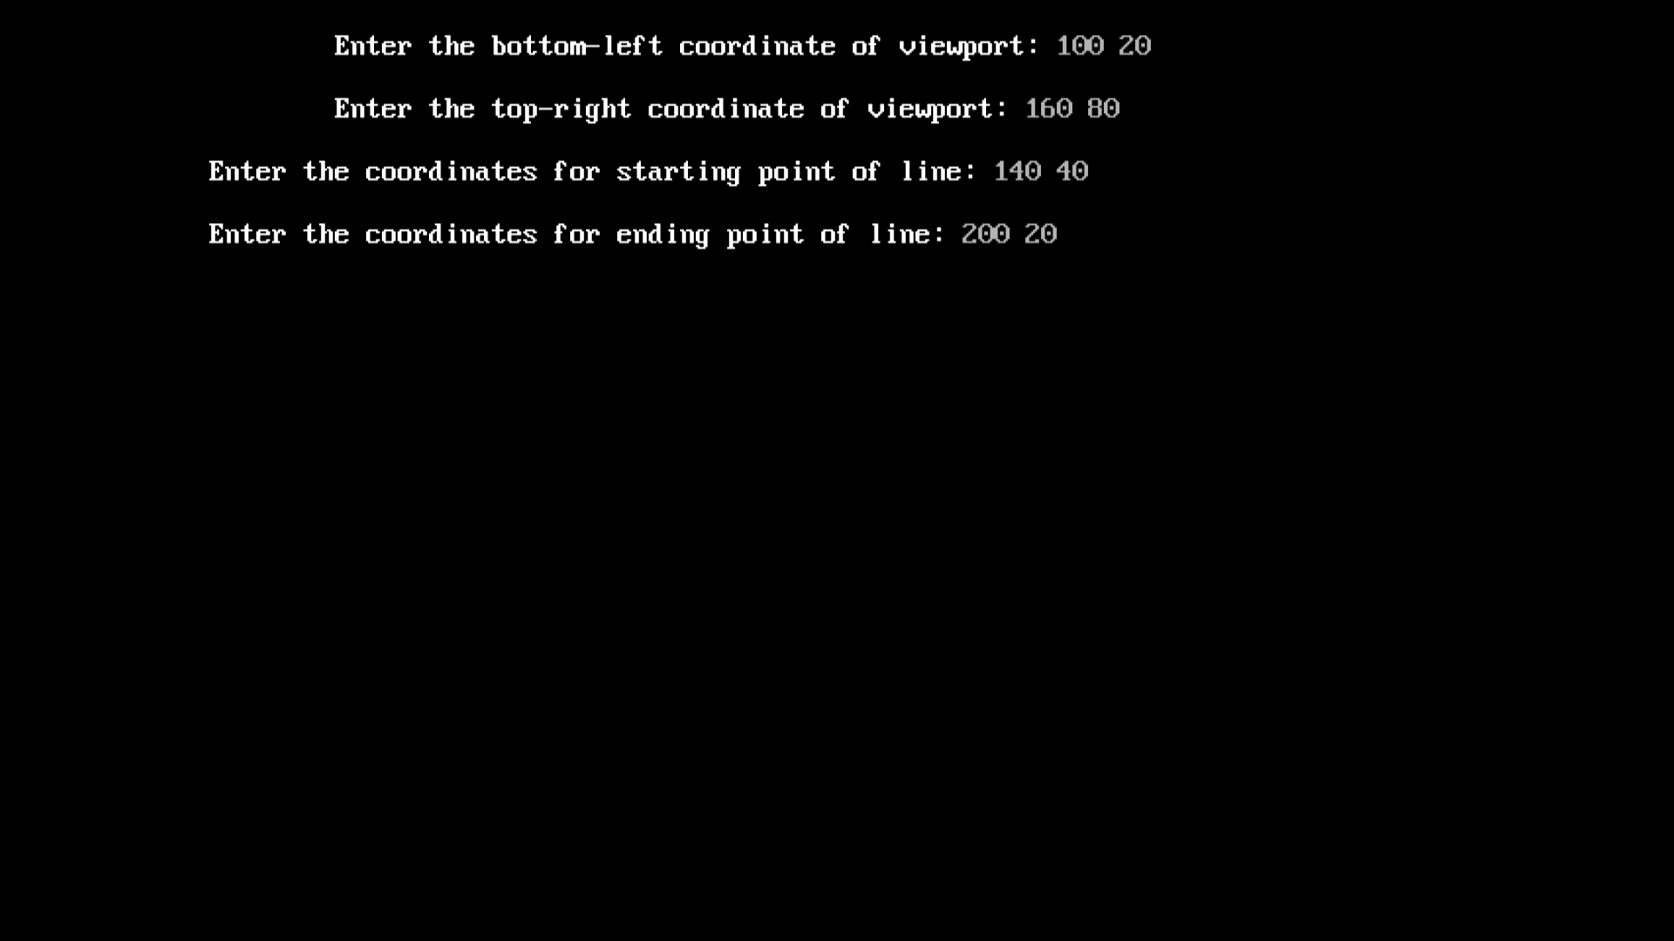

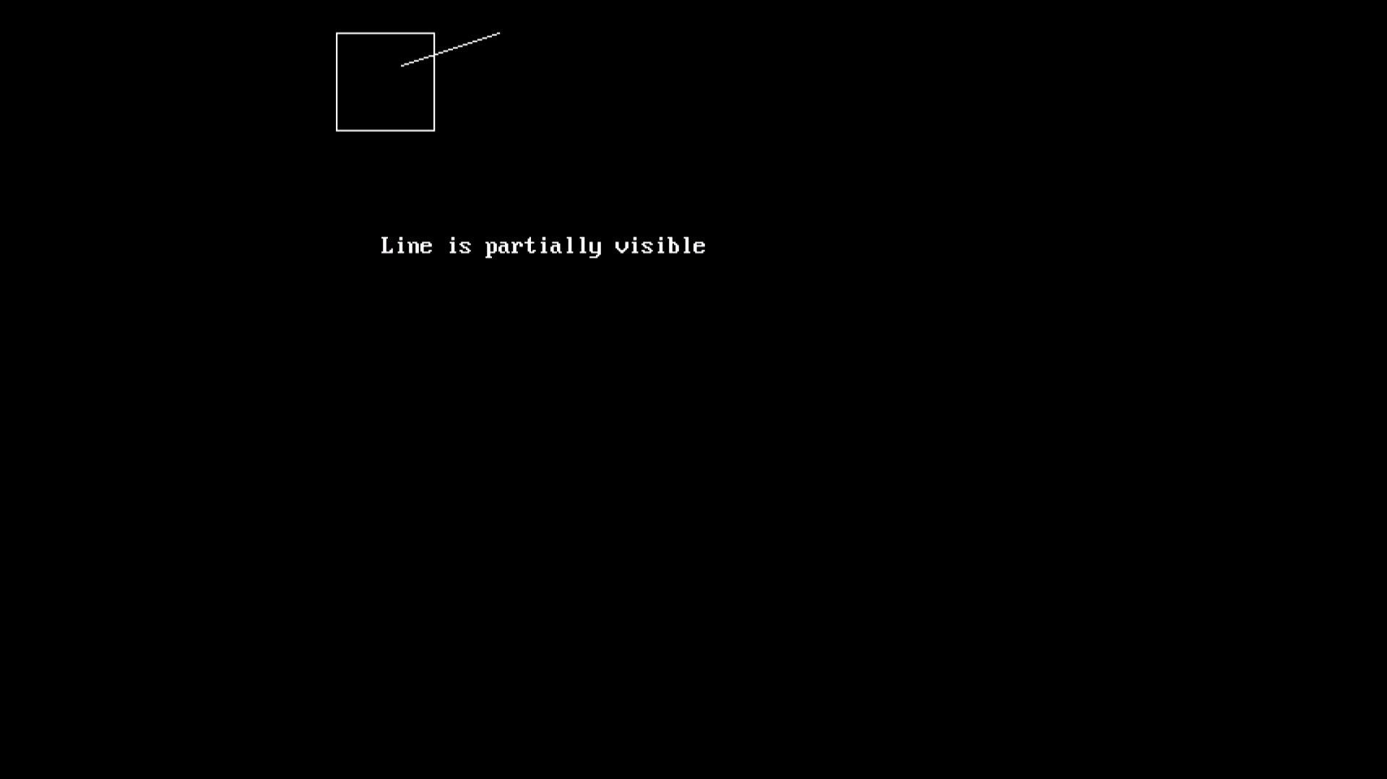

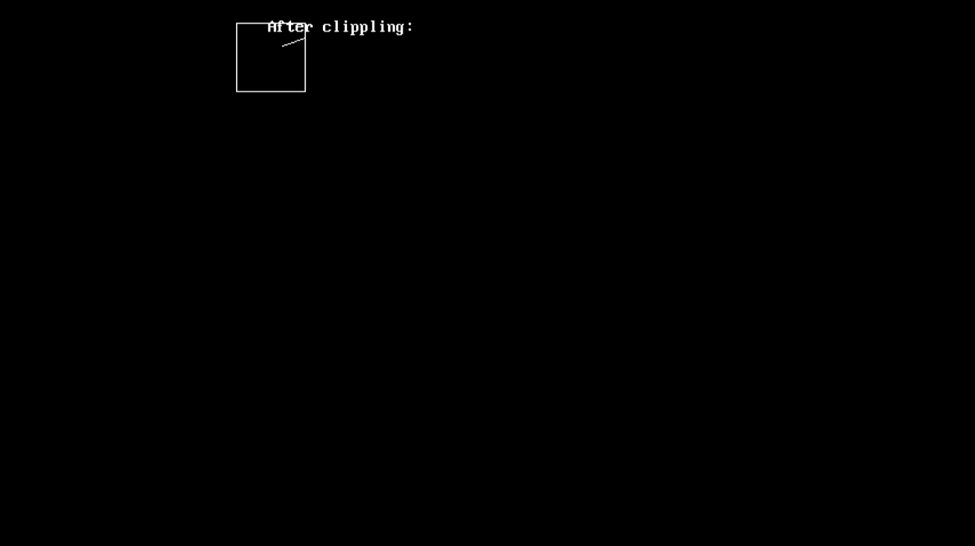

**PRACTICAL 09**

**AIM: *Write a program to implement Reflection of a line.***

**SOFTWARE REQUIRED: TURBO C++**

**PROGRAM:**

#include<stdio.h>

#include<conio.h>

#include<graphics.h>

void main()

{

int gd=DETECT,gm;

int x1,y1,x2,y2,a;

clrscr();

initgraph(&gd,&gm,"C:\\TURBOC3\\BGI");

printf("enter the coordinates of line");

scanf("%d%d%d%d",&x1,&y1,&x2,&y2);

line(x1,y1,x2,y2);

line(320,0,320,420);

line(0,240,640,240);

printf("enter 1 for reflection of line to x-axis AND enter 2 for y-axis\n");

scanf("%d",&a);

if(a==1)

{

line(x1+220,y1,x2+220,y2);

}

else if(a==2)

{

line(x1,y1+220,x2,y2+220);

}

else

{

printf("WRONG INPUT");

}

getch();

closegraph();

}

**OUTPUT**

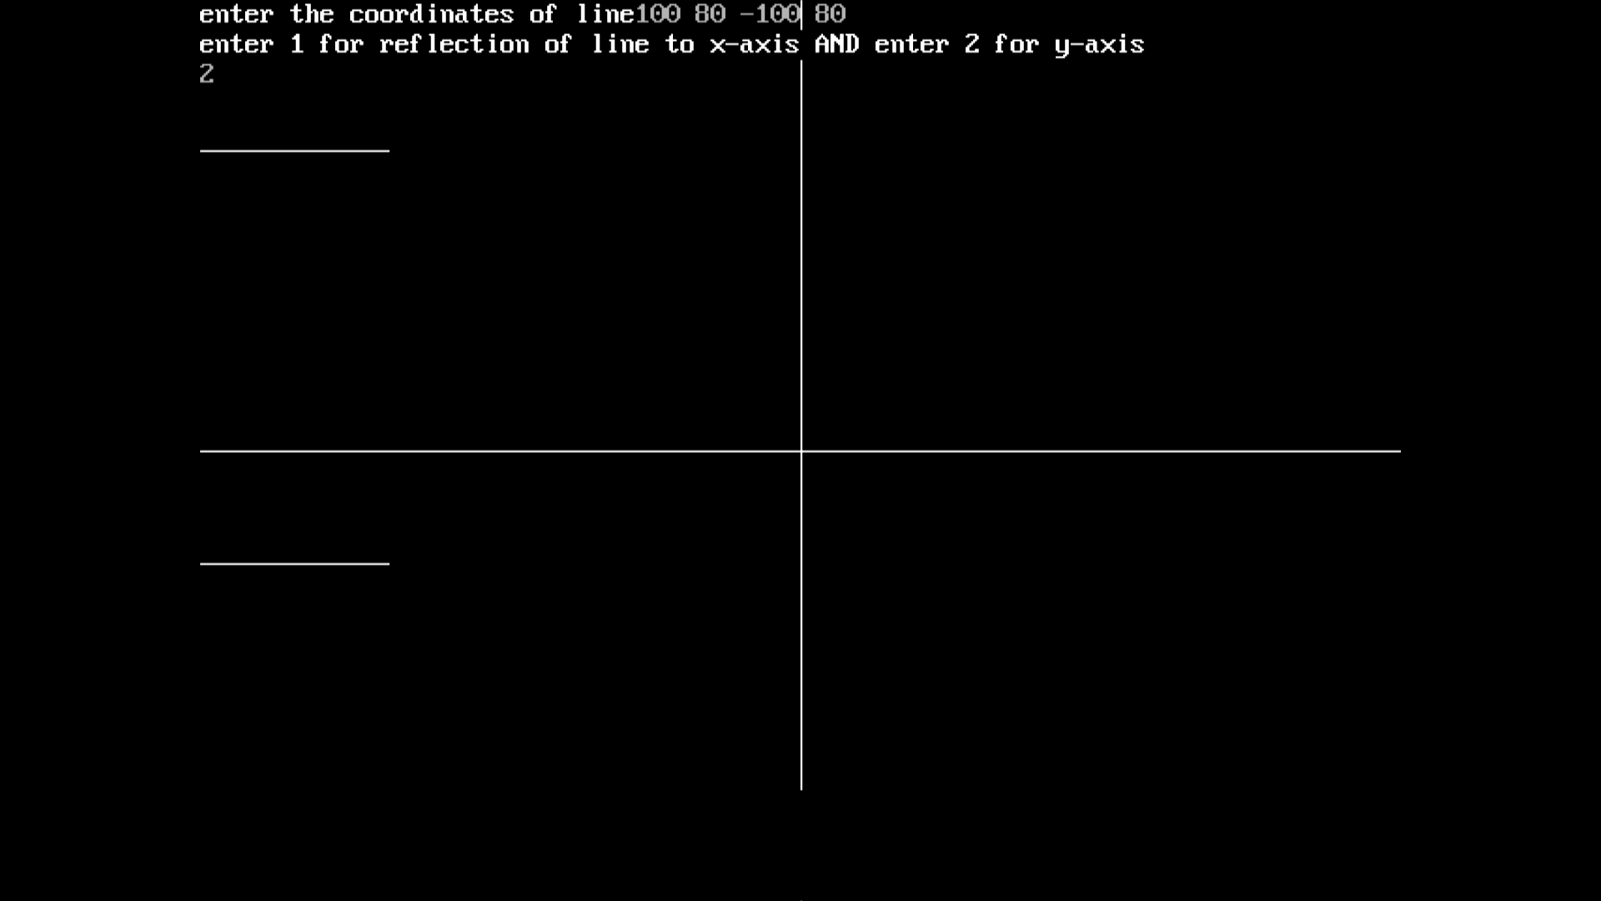

**PRACTICAL 01**

**AIM: *Write a program to implement DDA Algorithm.***

**SOFTWARE REQUIRED: TURBO C++**

**PROGRAM:**

#include<stdio.h>

#include<conio.h>

#include<graphics.h>

void main(){

int gd=DETECT,gm,x1,y1,x2,y2,x,y,length,dx,dy,xx,yy,i;

initgraph(&gd,&gm,"C:\\Turboc3\\BGI");

printf("enter starting and ending co-ordinates");

scanf("%d %d %d %d",&x1,&y1,&x2,&y2);

x=x2-x1;

y=y2-y1;

if( abs(x2-x1)>=abs(y2-y1) ){

length=abs(x2-x1);}

else

length=abs(y2-y1);

dx=(x2-x1)/length;

dy=(y2-y1)/length;

x=x1+0.5;

y=y1+0.5;

i=1;

while(i<=length){

putpixel(x,y,BLUE);

x=x+dx;

y=y+dy;

i=i+1;}

getch();

closegraph();}

**OUTPUT**

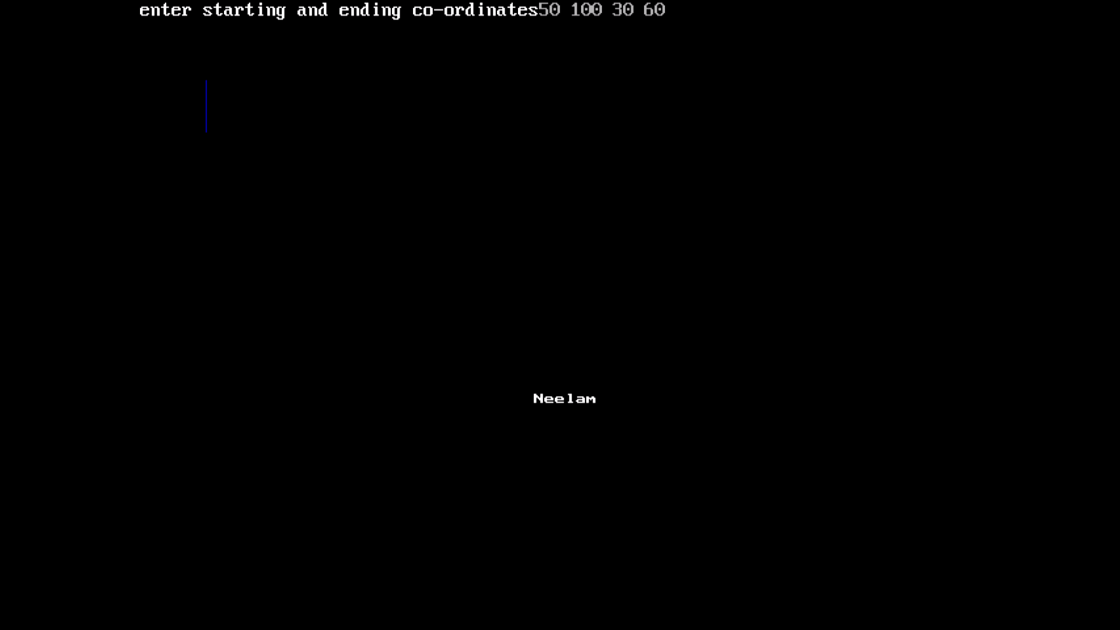

**PRACTICAL 02**

**AIM: *Write a program to implement Bresenham’s Algorithm.***

**SOFTWARE REQUIRED: TURBO C++**

**PROGRAM:**

#include<stdio.h>

#include<conio.h>

#include<graphics.h>

void main()

{

int gd=DETECT,gm,x1,y1,x2,y2,x,y,dx,dy,p;

initgraph(&gd,&gm,"C:\\Turboc3\\BGI");

printf("enter starting and ending points of line");

scanf("%d %d %d %d",&x1,&y1,&x2,&y2);

putpixel(x1,y1,RED);

x=x1;

y=y1;

dx=x2-x1;

dy=y2-y1;

p=(2*dy)-dx;

while(x<x2)

{

if(p<0)

{

x=x+1;

y=y;

p=p+(2*dy);

}

else

{

x=x+1;

y=y+1;

p=p+(2*dy)-(2*dx);

}

putpixel(x,y,RED);

}

getch();

closegraph();

}

**OUTPUT**

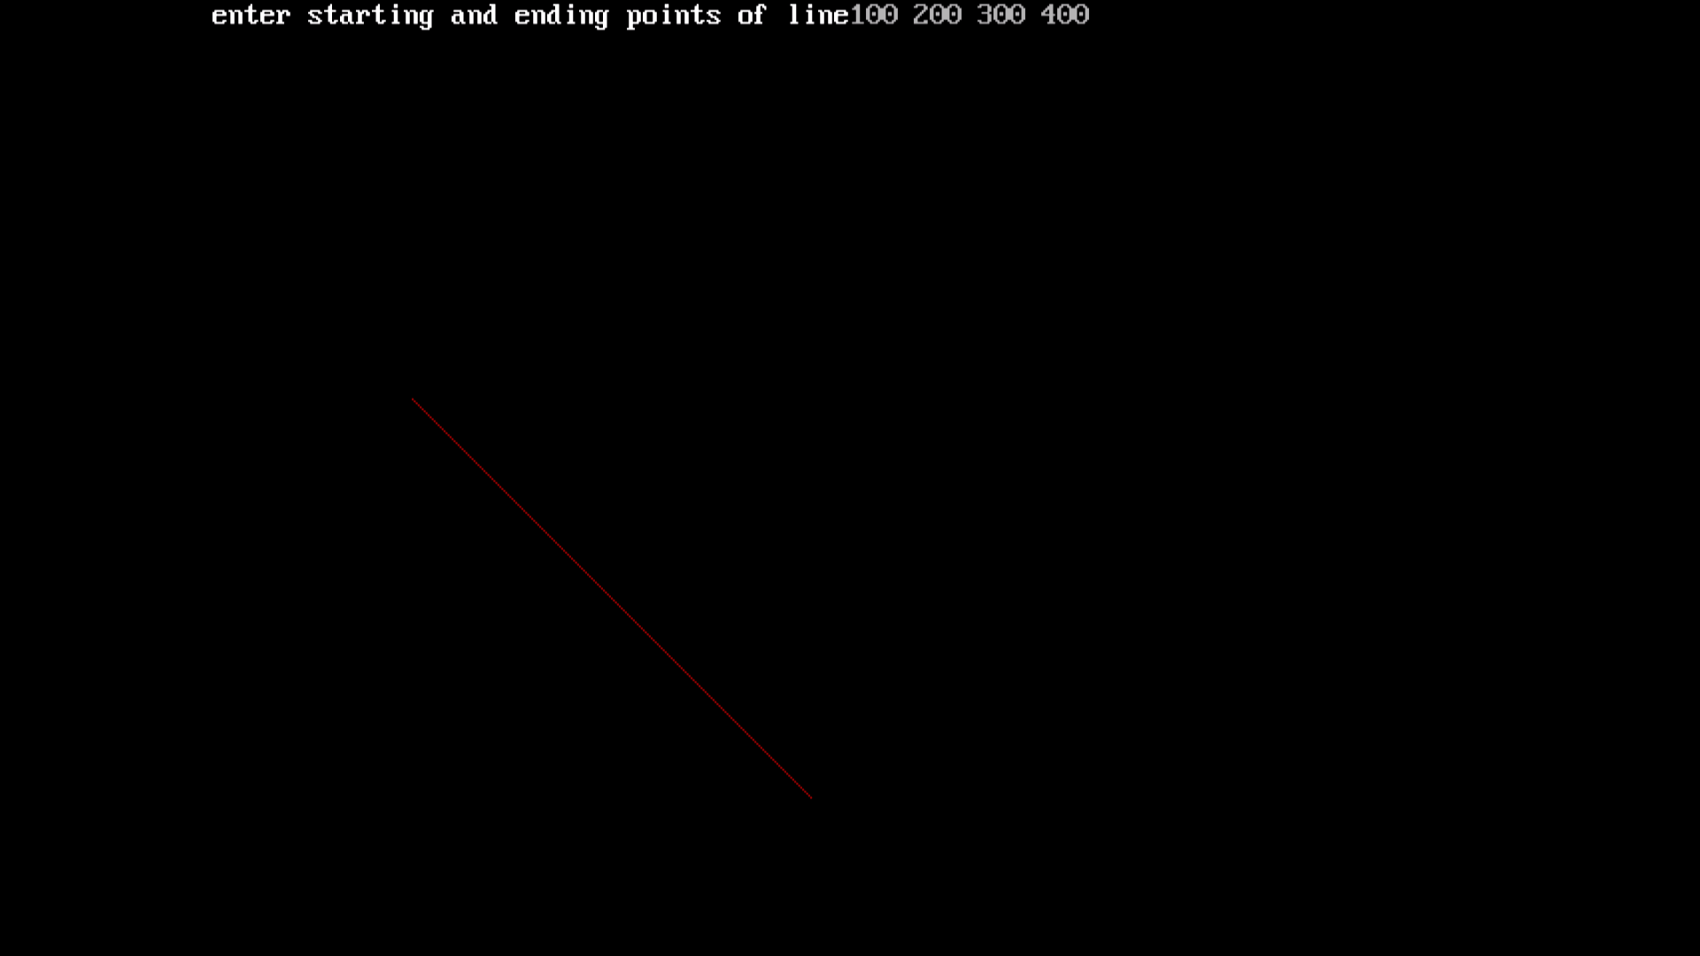

**PRACTICAL 03**

**AIM: *Write a program to draw a circle using Bresenham’s Circle Algorithm.***

**SOFTWARE REQUIRED: TURBO C++**

**PROGRAM:**

#include<stdio.h>

#include<conio.h>

#include<graphics.h>

void main()

{

int xc,yc,x,y,r,p;

int gd=DETECT,gm;

initgraph(&gd,&gm,"C:\\TurboC3\\BGI");

printf("enter raduis");

scanf("%d",&r);

printf("enter co ordinates");

scanf("%d%d",&xc,&yc);

x=0;

y=r;

p=3-(2*r);

while(x<=y)

{

putpixel(xc+x,yc+y,1);

putpixel(xc-y,yc-x,2);

putpixel(xc+y,yc-x,3);

putpixel(xc-y,yc+x,4);

putpixel(xc+y,yc+x,5);

putpixel(xc-x,yc-y,3);

putpixel(xc+x,yc-y,7);

putpixel(xc-x,yc+y,8);

if(p<0)

{

x=x+1;

y=y;

p=p+(4*x)+6;

}

else

{

x=x+1;

y=y-1;

p=p+(4*(x-y))+10;

}}

getch();

closegraph();

}

**OUTPUT**

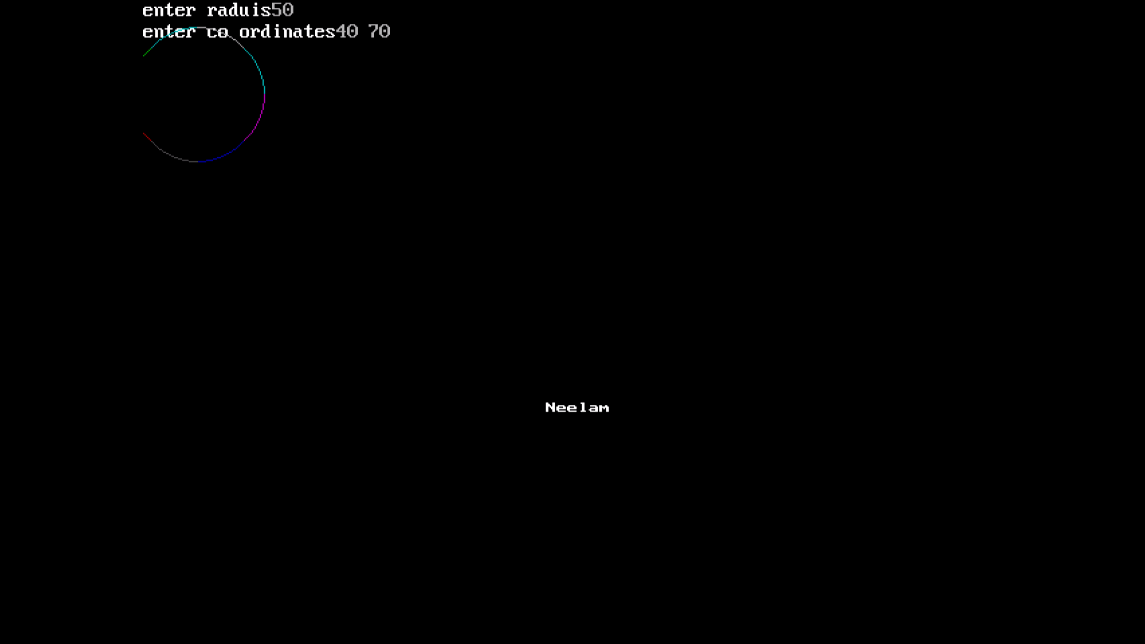

**PRACTICAL 04**

**AIM: *Write a program to perform Scaling.***

**SOFTWARE REQUIRED: TURBO C++**

**PROGRAM:**

#include<stdio.h>

#include<conio.h>

#include<graphics.h>

void main(){

intgd=DETECT,gm,x1,y1,x2,y2,x3,y3,sc;

initgraph(&gd,&gm,"C:\\Turboc3\\BGI");

printf("enter triangle cordinates");

scanf("%d %d %d %d %d %d",&x1,&y1,&x2,&y2,&x3,&y3);

line(x1,y1,x2,y2);line(x2,y2,x3,y3);line(x1,y1,x3,y3);

printf("enter the scaling factor");

scanf("%d",&sc);

printf("after scaling");

line(x1*sc,y1*sc,x2*sc,y2*sc);

line(x2*sc,y2*sc,x3*sc,y3*sc);

line(x1*sc,y1*sc,x3*sc,y3*sc);

getch();

closegraph();}

**OUTPUT**

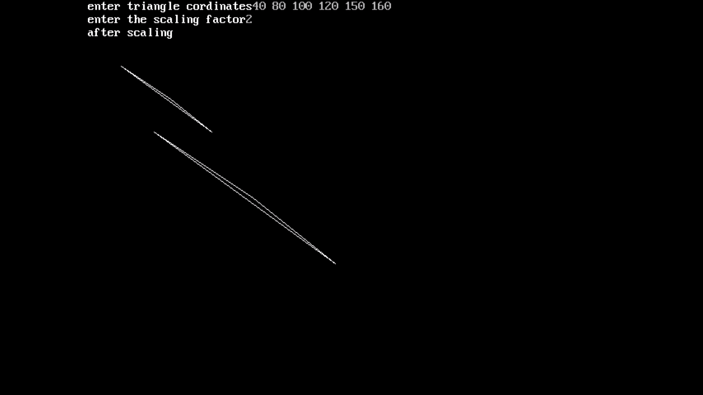

**PRACTICAL 05**

**AIM: *Write a program to perform Rotation.***

**SOFTWARE REQUIRED: TURBO C++**

**PROGRAM:**

#include<stdio.h>

#include<conio.h>

#include<graphics.h>

#include<math.h>

void main(){

intgd=DETECT,gm,x1,y1,x2,y2,x3,y3,a;

initgraph(&gd,&gm,"C:\\Turboc3\\BGI");

printf("enter the cordinates to perform a traingle");

scanf("%d %d %d %d %d %d",&x1,&y1,&x2,&y2,&x3,&y3);

line(x1,y1,x2,y2);

line(x2,y2,x3,y3);

line(x1,y1,x3,y3);

printf("enter the angle of rotation");

scanf("%d",&a);

x1=((x1*cos(a))-(y1*cos(a)));

y1=((x1*sin(a))+(y1*cos(a)));

x2=((x2*cos(a))-(y2*cos(a)));

y2=((x2*sin(a))+(y2*cos(a)));

x3=((x3*cos(a))-(y3*cos(a)));

y3=((y3*sin(a))+(y3*cos(a)));

printf("after rotation");

line(x1,y1,x2,y2);line(x2,y2,x3,y3);line(x1,y1,x3,y3);

getch();

closegraph();}

**OUTPUT**

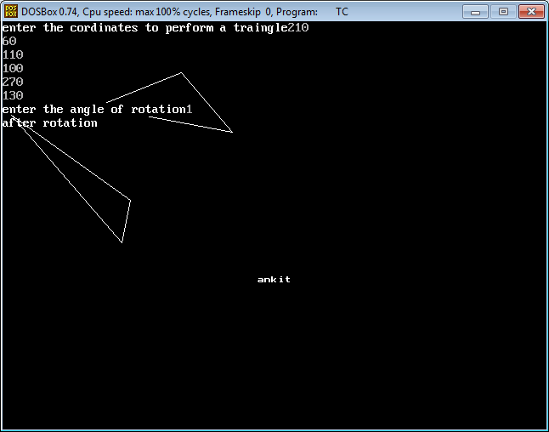

**PRACTICAL 06**

**AIM: *Write a program to perform Composite Scaling.***

**SOFTWARE REQUIRED: TURBO C++**

**PROGRAM:**

#include<stdlib.h>

#include<conio.h>

#include<iostream.h>

#include<math.h>

void main()

{

int graphdriver=DETECT,graphmode,errorcode;

int i,Sx,Sy,Xf,Yf,x1,x2,x3,y1,y2,y3,j,k;

int t[3][3], l[3][3], f[3][3];

initgraph(&graphdriver,&graphmode,"c:\\turboc3\\bgi");

cout<<"Enter the first coordinates of triangle(x1,y1):";

cin>>x1>>y1;

cout<<"Enter the first coordinates of triangle(x2,y2):";

cin>>x2>>y2;

cout<<"Enter the first coordinates of triangle(x3,y3):";

cin>>x3>>y3;

line(x1,y1,x2,y2);

line(x1,y1,x3,y3);

line(x2,y2,x3,y3);

cout<<"Enter the value of scaling factors (Sx,Sy):";

cin>>Sx>>Sy;

cout<<"Enter the coordinates of triangle you want to be fix(Xf,Yf):";

cin>>Xf>>Yf;

t[0][0]=Sx;

t[0][1]=0;

t[0][2]=Xf*(1-Sx);

t[1][0]=0;

t[1][1]=Sy;

t[1][2]=Yf*(1-Sy);

t[2][0]=0;

t[2][1]=0;

t[2][2]=1;

l[0][0]=x1;

l[0][1]=x2;

l[0][2]=x3;

l[1][0]=y1;

l[1][1]=y2;

l[1][2]=y3;

l[2][0]=1;

l[2][1]=1;

l[2][2]=1;

for (i = 0; i < 3; i++)

{

for (j = 0; j < 3; j++)

{

f[i][j] = 0;

for (k = 0; k < 3; k++)

f[i][j] += t[i][k]*l[k][j];

}

}

x1=f[0][0];

x2=f[0][1];

x3=f[0][2];

y1=f[1][0];

y2=f[1][1];

y3=f[1][2];

cout<<"\nAfter scaling\n\n";

setcolor(RED);

line(x1,y1,x2,y2);

line(x1,y1,x3,y3);

line(x2,y2,x3,y3);

getch();

closegraph();}

**OUTPUT**

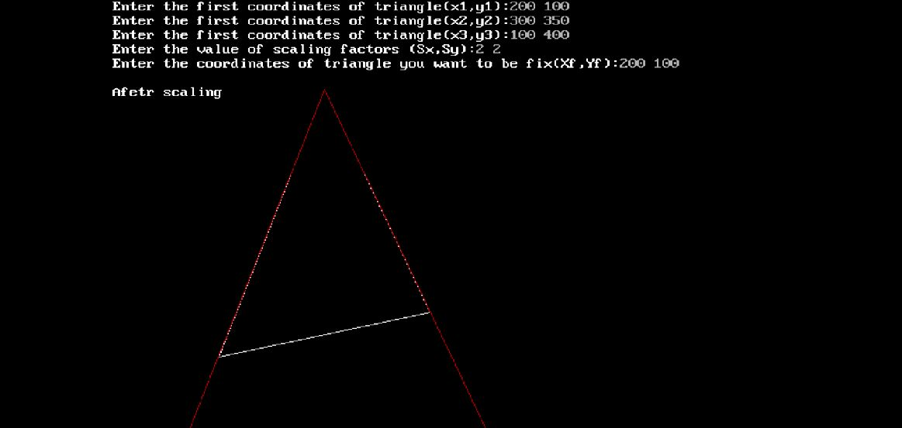

**PRACTICAL 07**

**AIM: *Write a program to perform Composite Rotation.***

**SOFTWARE REQUIRED: TURBO C++**

#include<graphics.h>

#include<stdlib.h>

#include<conio.h>

#include<iostream.h>

#include<math.h>

void main()

{

int graphdriver=DETECT,graphmode,errorcode;

double i,Xr,Yr,x1,x2,x3,y1,y2,y3,j,k;

double t[3][3], l[3][3], f[3][3];

double th;

initgraph(&graphdriver,&graphmode,"c:\\turboc3\\bgi");

cout<<"Enter the first coordinates of line(x1,y1):";

cin>>x1>>y1;

cout<<"Enter the first coordinates of line(x2,y2):";

cin>>x2>>y2;

cout<<"Enter the first coordinates of line(x3,y3):";

cin>>x3>>y3;

line(x1,y1,x2,y2);

line(x1,y1,x3,y3);

line(x2,y2,x3,y3);

cout<<"Enter the rotation angle (theta):";

cin>>th;

cout<<"Enter the coordinates of pivot point(Xr,Yr):";

cin>>Xr>>Yr;

t[0][0]=cos((th*3.1428)/180);

t[0][1]=(-sin((th*3.1428)/180));

t[0][2]=(Xr*(1-cos((th*3.1428)/180))+Yr*(sin((th*3.1428)/180)));

t[1][0]=sin((th*3.1428)/180);

t[1][1]=cos((th*3.1428)/180);

t[1][2]=(Yr*(1-cos((th*3.1428)/180))-Xr*(sin((th*3.1428)/180)));

t[2][0]=0;

t[2][1]=0;

t[2][2]=1;

l[0][0]=x1;

l[0][1]=x2;

l[0][2]=x3;

l[1][0]=y1;

l[1][1]=y2;

l[1][2]=y3;

l[2][0]=1;

l[2][1]=1;

l[2][2]=1;

for (i = 0; i < 3; i++)

{

for (j = 0; j < 3; j++)

{

f[i][j] = 0;

for (k = 0; k < 3; k++)

f[i][j] += t[i][k]*l[k][j];

}

}

x1=f[0][0];

x2=f[0][1];

x3=f[0][2];

y1=f[1][0];

y2=f[1][1];

y3=f[1][2];

cout<<"\nAfetr rotation\n\n";

line(x1,y1,x2,y2);

line(x1,y1,x3,y3);

line(x2,y2,x3,y3);

getch();

closegraph();

}

**OUTPUT**

